DATE: 05.04.2019
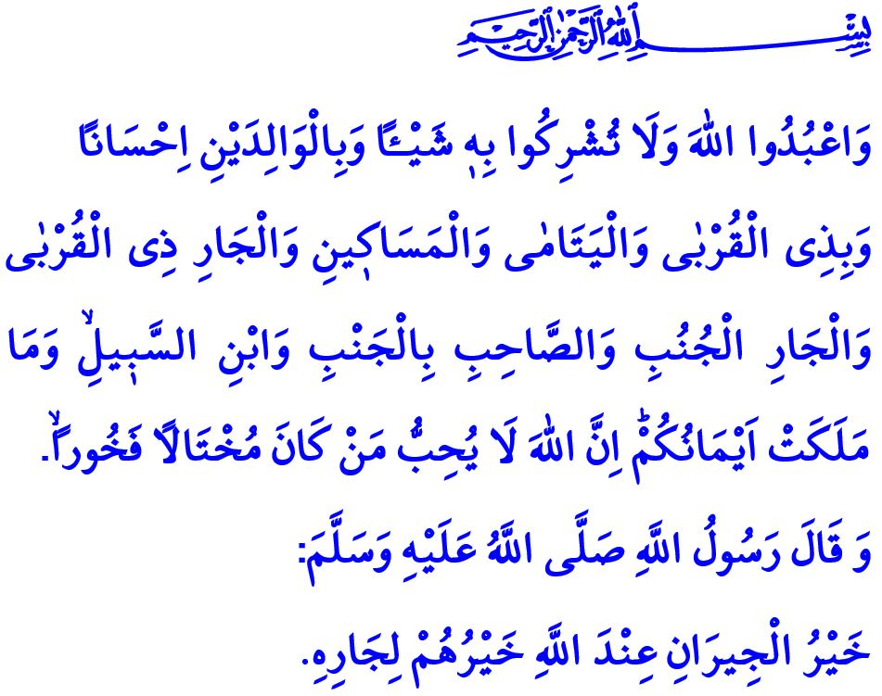
MUSLIMS ARE BENEFICENT NEIGHBOURS
Dear Muslims!
Allah the Almighty (swt) states in the verse I have just recited: “Serve Allah, and join not any partners with him. And do good to parents, kinsfolk, orphans, those in need, neighbours who are near, neighbours who are strangers, the companion by your side, the wayfarer (ye meet), and what your right hands possess. For Allah loveth not the arrogant, the vainglorious.”
The Messenger of Allah (saw) states in the hadith I have read: “The best neighbour in Allah's estimation is the one who is best to his neighbour.”
Dear Believers!
Neighbourhood is an inseparable part of our social life. Our neighbours are the people with whom we encounter every day, to whose soothing and assuring salaam we are accustomed, and who stand by us when we need. Our village, quarter, district, province, and country also have neighbours. The main principle in all neighbourhood relations is equity, kindness, respect, and mercy. A neighbour who has ethical virtues, respects humanitarian values and protects honour and dignity of his neighbour is one of the biggest blessings of the life in this world.
Honorable Muslims!
So many rights have neighbours upon each other that Our Beloved Prophet (saw) states: “Gabriel kept on commending the neighbour to me so that I thought he would make an heir.” Favouring the neighbours and being nice to them, with the expression of Our Prophet (saw), is a necessity of being a believer.
Believers do not leave their neighbours alone and helpless, in accordance with the maturity of their faith. They support their neighbours both materially and spiritually for whatever they need. So much so that a believer woman knows while even cooking that it is the Prophet’s (saw) recommendation to add some extra water to the soup for the favour of her neighbour. It is a neighbourhood duty to share good and bad days, visit them when they are sick, be present at their funeral and look out for their family members in case of their death.
Dear Believers!
How sorrowful it is that so many neighbours who live under the roof of the same apartment building and lean on the same wall in the evenings do not know each other today. Neighbours deny each other to even a salaam, the pains suffered are heard after days and happiness stays within the walls of houses. Today’s people neglect their souls and hearts and fail to notice the neighbourhood relations that can help to solve their problems. With the weakening of neighbourhood relations, unfortunately, our good characteristics such as knowing, understanding, tolerating, and forgiving each other are disappearing.
Honorable Believers!
Let us this Friday, we the believers, question to what extent we comply with neighbourhood ethics and rights. Let us not neglect to salaam our neighbours warmly and sincerely, ask how the children are, and smile to the young people. Let us share grieves and happiness of our neighbours. Let us pay attention to the graveness of the warning of Our Prophet (saw) who says: “He will not enter Paradise whose neighbour is not secure from his wrongful conduct.” Let us show ultimate sensitivity not to damage our neighbours by our hands or words. Let us accept the hadith of Our Prophet (saw), “A man is not a believer who fills his stomach while his neighbour is hungry” as touchstone. Who was the last neighbour of ours that we visited or hosted in our house? Let us ask ourselves.
Dear Muslims!
Establishing good relations with neighbours is a necessity of our faith just like worship. Our ethics require making the senses of love, respect, cooperation and solidarity dominant in our neighbourhood relations.
Let us ask the goodness of our neighbour just like we ask it for ourselves. Let us protect our neighbour from the evil that we do not desire for ourselves. Let our hearts be neighbour, as well as our bodies.

Al-Nisâ, 4/36.
Dârimî, Siyer, 3; Tirmizî, Birr, 28.
Tirmizî, Birr, 28.
İbn Mâce, Zühd, 24; Tirmizî, Zühd, 2.
Muslim, Îmân, 73.
Beyhakî, es-Sünenü’l-kübrâ, X, 7. General Directorate of Religious Services

